FROM: THE COCA-COLA COMPANY PRIZE REDEMPTION CENTRE
2016 COCA-COLA WORLD PACIFIC PROMOTION REWARDS.
WEB SITE: WWW.MYCOKEREWARDS.COM.

Dear Winner,

This is to inform you that you have won the total sum of $750.000.00 USD (Seven Hundred And Fifty Thousand United States Dollars) for this 2016 International E-mail Draw which was Organized and Sponsored by The Coca-Cola Company Promotions Department (CCPD).

Your email address is among the winners in a random World Wide Web computerized draw system, extracted from over a million companies and individual email address of the people that are active online. This promotional draw is conducted in the United Kingdom but email entries were drawn on a global basis.

Six people are selected yearly to benefit from this award and you are one of the Selected Winners, Prize award must be claimed not later than 7 working days from the date of Draw Notification. Any Prize not claimed within this period will be confiscate and transfer to charity organizations.

You have to contact our Regional Head Office in United Kingdom with the contact details below;

Name: Mr. Damien Lewis.
(Director, Claim Department)
#1 Queen Caroline Street
Hammersmith
London
W6 9HQ
Telephone: +447024008237
E-mail: redemption-dept@yandex.com

You have to provide the following information for the processing of your winning prize (fund).
NAME:
ADDRESS:
NATIONALITY:
SEX:
AGE:
PHONE / MOBILE:
FAX:
OCCUPATION:
Your Email Attached to REF: GML-S343-KKT-8811 and BAT: 56T-DTH78-ZA99
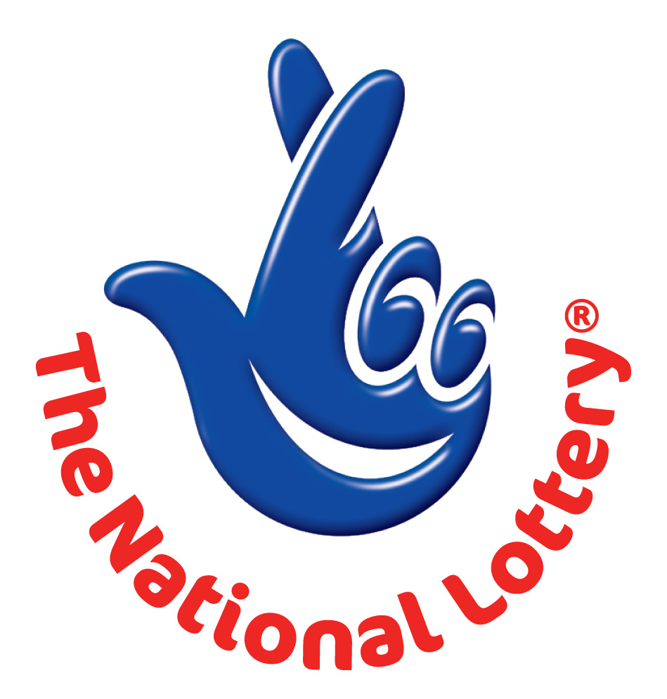
Yours Sincerely,
Mrs. Olga Becker
(Organising Committee)

