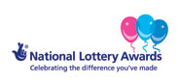

UK Award National Lottery
The Lottery Company Limited
4 PRINCES SQUARE
HARROGATE
NORTH YORKSHIRE, HG1 1LX
Company No. 02949433
(Customer Services)
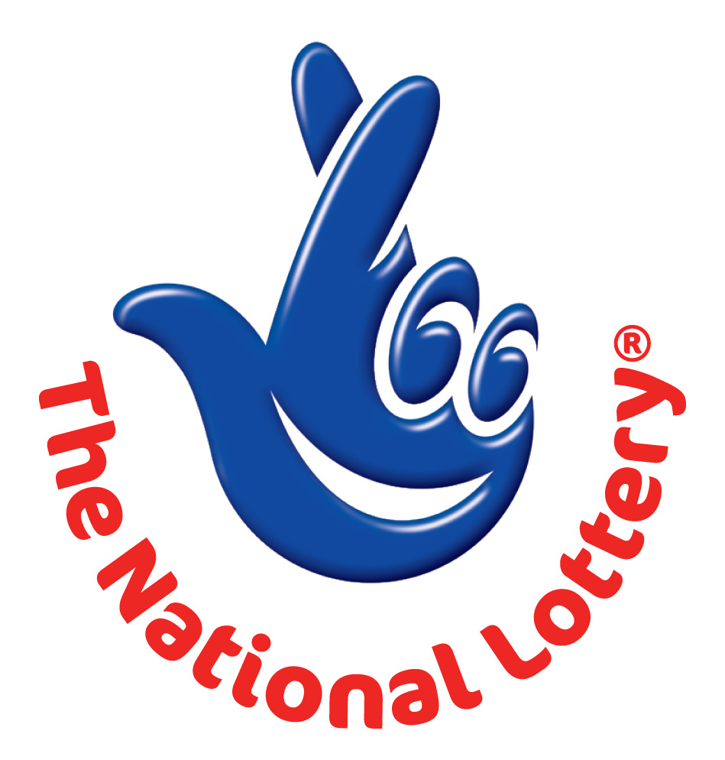
Ref: UK/GSC988533/09
Batch: 077/YG00/498

Attn: E-mail Holder,

OFFICIAL WINNING NOTIFICATION:

We officially announce to you the draw (#1354) Ball Set Used: 7 Machine Name Used: Amethyst of the UNITED KINGDOM AWARD NATIONAL LOTTERY, Online International program held on London and was officially Announced your e-mail address attached to ticket number: 566475422411 with Serial number 009744/06 drew the lucky numbers:
Bonus ball no which subsequently won you the lottery in the 2nd category i.e.

Match 5 numbers. You have therefore been approved to claim a total sum of £650.000.00GBP (Six Hundred And Fifty Thousand Great Pounds Starlings) in cash credited to file UK/GSC988533/09.

This is from a total cash prize of £9,135,956.00GBP shared amongst the lucky winners All Participants for the online version were selected randomly from World Wide Web sites through computer draw system and extracted from over 100,000 unions, associations, and corporate bodies that are listed online which are America, Africa, Asia, Australia, Europe, Middle East, and Oceania.

This award promotion takes place in this August. Please note that your lucky winning number falls within our Europe booklet representative office as indicated in your play coupon.

In view of this, You have therefore been approved to claim a total sum of You have therefore been approved to claim a total sum of £650.000.00GBP (Six Hundred And Fifty Thousand Great Pounds Starlings) would be released to you By any of our payment offices in Europe They will commence the process to facilitate the release of your funds As soon as you contact them.

For security reasons, you are advised to keep your winning information confidential till your claims is processed and your money remitted to you in whatever manner you deem fit to claim your prize.

This is part of our precautionary measure to avoid double claiming and unwarranted abuse of this program. Please be warned. To file for your Claim, please contact our Claim Service Centre in United Kingdom:

UK Claim Service Centre
E-mail: ukclaimdept@aol.co.uk
E-mail: uklotterycentre@winning.com
Tel/Fax: +44 702 406 4982

For further clarification/verification of your claims, Please contact our Claim Service Centre in United Kingdom stated in this notification e-mail.
Good luck and congratulation from all members of staff of the UK NATIONAL LOTTERY.

Yours faithfully,
Mrs. Callie Surtees
Online Coordinators for UK Award National Lottery
International Program

Material Copyright © 2009 the Lottery Co. Ltd. The Lottery Company is in no way affiliated with, associated with or approved or endorsed by Camelot Group plc or The National Lottery Commission.

