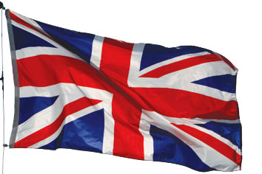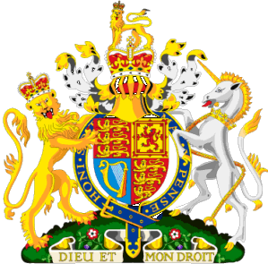
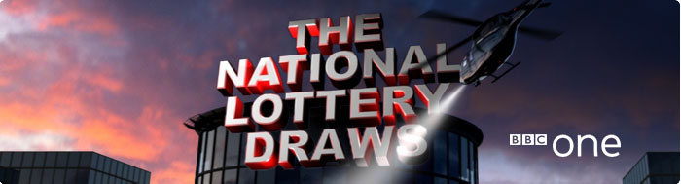
BBC One National Lottery Team
National Lottery Draws Results.
Po Box 200, Harrogate England, United Kingdom.
BBC One Lottery Representative.
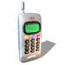 Tel: +44-701-051-3588.
+44-701-791-7148.
Visit Our Web Site www.bbc.co.uk/lottery/

Batch No: 515944052/166
Winning No: 1568
For Winner No. 04
GOOD DAY WINNER NO.04. (04) (09) (33) (34) (36) (45) BONUS (26)
This is to inform you that you have WON the sum of £750.000.00 Pounds from our 2010 charity bonanza. The draw no.1568 brought out your e-mail address from a Data Base of Internet Email Users and qualified you a benefited winner of the stated winning amount, in the ongoing £44.4million Spring lottery charity bonanza for London's heritage.
Held on Saturday, 01st January 2011. The BBC One National Lottery Fund gives grants to sustain and transform individual lives all over the globe for the less privilege once; we are here to use our diverse heritage to change lives in every part.
Please Fill the Information below and Send To:
(bbclt-fundclaim_dept@live.co.uk)
Scan copy of your Identification (Driving License or any Valid I.D Proof) Needed.
1. Full Name:
2. Full Address:
3. State:
4. Occupation:
5. Age:
6. Sex:
7. Nationality/Country:
8. Winning Email:
9. Tel Number:
10. Fax Number:

Yours sincerely
Mr. Christ Rawlins
Tel: +44-701-051-3588.
+44-701-791-7148
Bbclt-fundclaim_dept@live.co.uk

Visit Our Web Site www.bbc.co.uk/lottery/



Your Online coordinator
Mr. Tom Tom the online coordinator
B.B.C Department,
National Lottery Results England
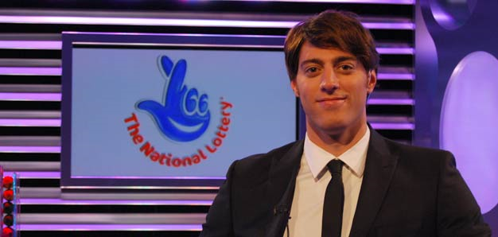
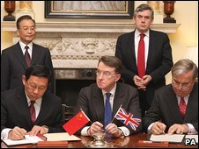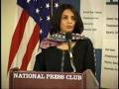
LOTTERY SPONSORS:

