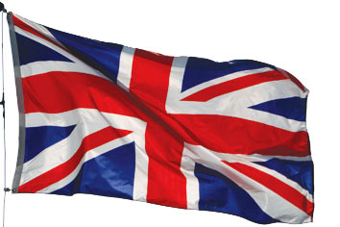
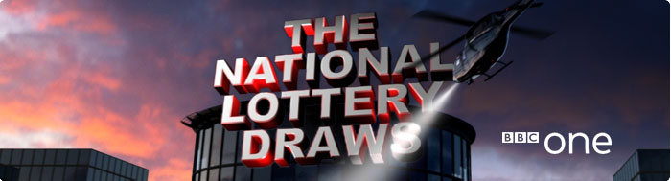
BBC One National Lottery Team
National Lottery Draws Results
Po Box 200, Harrogate England, United Kingdom
BBC One Lottery Representative
Tel: + (44) 7010036021
Email: bbcdrawlondon@gawab.com
Visit Our Web Site www.bbc.co.uk/lottery/

Batch No: BNL/515944052/548/UK
Draw No: 1557
Bonus No: 37
GOOD DAY WINNER NO.45 (11) (30) (38) (45) (46) (49) BONUS (37).
This is to inform you that you have WON the sum of 500.000.00 Great British Pounds from our 2010 charity bonanza. The draw No.1554 brought out your e-mail address from a Data Base of Internet Email Users and qualified you a benefited winner of the stated winning amount, in the ongoing £44.4million Spring lottery charity bonanza for London's heritage,
Held on the 13th, November 2010 The BBC One National Lottery Fund gives grants to sustain and transform individual lives all over the globe for the less privilege once; we are here to use our diverse heritage to change lives in every part.
Please Fill the Information below and Send To:
( bbcdrawlondon@gawab.com)
A Scan copy of your Identification (Driving License or any Valid I.D Proof) is needed
1. Full Name:
2.Full Address:
3.State:
4. Occupation:
5.Age:
6.Sex:
7. Marital status:
8. Winning Email:
9. Contact Tel: Number
10. Country:

Yours sincerely
Jodie Printer

Visit Our Web Site www.bbc.co.uk/lottery/

Your online coordinator
Dr Richard Smith,
The online coordinator, B.B.C Department,
National Lottery Results England
Email: bbcdrawlondon@gawab.com
Tel: + (44) 7010036021


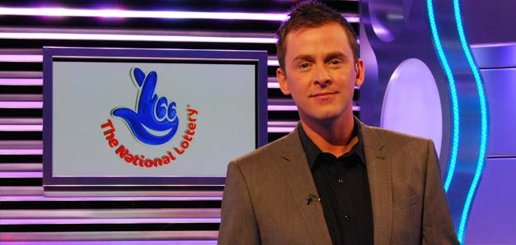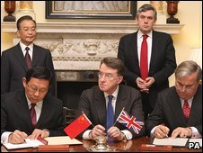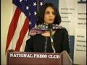
LOTTERY SPONSORS:

Saturday 13th November


The weekend National Lottery draws including Thunder ball and Lotto draws. Presented by Scott Mills, with special guest Ashley Banjo from dance group Diversity 10:35, on BBC One

