


YAHOO EMAIL LOTTERY
103 Gaunt Street,London, SE1 6DP- United Kingdom.

This is to inform you that your email address have won you a prize money of One Million United States Dollars (USD$1,000,000.00) for 2011 (EBS) Electronic Balloting System Award Promotion which is organized by YAHOOMAIL & WINDOWS LIVE, in the 2011 YAHOOMAIL and MICRO SOFT gathered all the email users that are active online, among the millions that were selected for this EBS promotion your email was among the twenty that were selected as our winner for this year 2011 and because of it we decided to send you this notification for you to come for your claim as one of the 20th winner of this year award promotion.
PAYMENT OF PRIZE AND CLAIM.
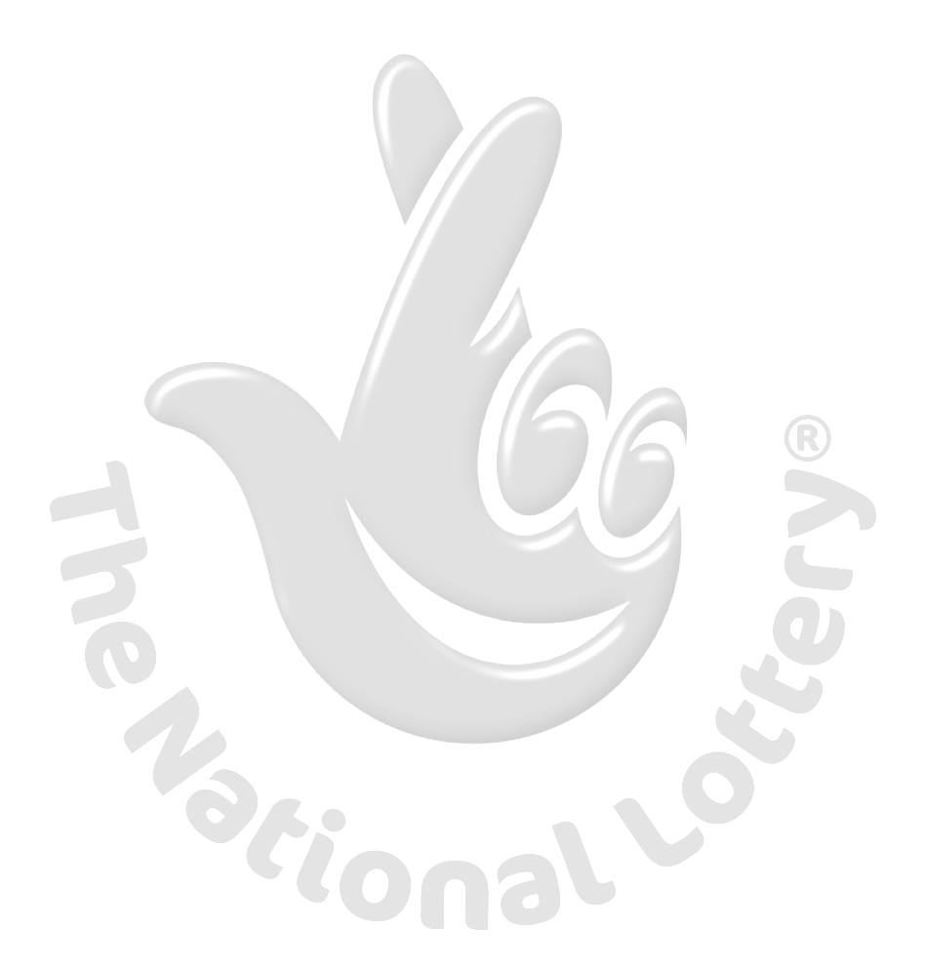
Winners shall be paid in accordance with his/her Settlement Center. Yahoo Prize Award must be claimed no later than 14 days, from date of Draw Notification. Any prize not claimed within this period will be forfeited. Stated below are your identification numbers: BATCH NUMBER: YBM-EBS390AF, REFERENCE NUMBER: YBM-EBS719AF, WINNING NUMBER: WBM-EBS-798AF These numbers fall within the United Kingdom Location file, you are requested to contact our fiduciary agent in London and send your winning identification numbers to him to facilitate your approval payment file:

NOTE: We have made it easier for our winners to claim there prizes without traveling out of there Countries, our affiliates bank will be doing a direct transferring of funds to each nominated bank account you may provide or by issuing of checks to whose option is to receive a check, Please pardon us, you have to reactivate an account with our affiliate bank to enable your prize that was into our fixed deposit account we had with the bank to be activated, so they can have access for the release of payment.

CLAIMS AGENT CONTACT INFORMATION:
NAME: DR.BROWN WILLIAMS
E-Mail: drbrownagents2011@gmail.com
TEL: +44702-4044660
+44702-4098944
You are to send the following information to your Claims Agent to procure your release approval documents.

1. Full name…………………………….
2. Contact address……………………
3. Telephone Number………………..
4. Age…………………………………….
5.Sex…………………………………….
5. Occupation…………………………..
6. Batch Number………………………
7. Reference Number…………………
8. Winning Number……………………….
Please note that a copy of your passport or your drivers license is needed while sending your information………………………….
Congratulations!! Once again.
Yours in service,
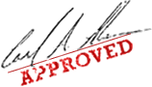
YAHOO LOTTERY ORGINZERS. MRS MICKY MOORE

