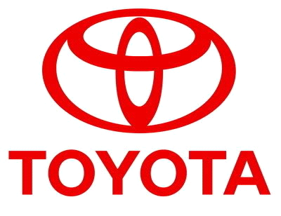

================================== TOYOTA AUTOMOBILES COMPANY
BURNASTON A38/A50, DERYSHIRE
EAST MIDLANDS DE1 9TA UNITED KINGDOM
TEL NO ++447017430097
(Customers Care Line)

STAR PRIZE WINNER
This is to inform you that your email id have won cash prize of (£500,000 00 GBP) from TOYOTA AUTOMOBILES promotion in 2012.uk station worldwide. Your Batch No: 515944052/166 and Winning No: 1544 make you as one of the lucky winner in our Charity bonanza and you are advice to keep the information of your winning confidential. to avoid double claim Congratulation once again.

Please Fill the Information below: TEL NO +447017430097
TEL NO +447017430097

1. Full Names:
2. Your Full Address:
3. Your Age:
4. Your country -
5. Your Country of resident -
6. Your City -
7. Your Occupation
8. Sex -
9. State:
10.Winning Email Address:
11. Your Mobile Number :

Contact Events Manager

Reply to: toyotanew221@hotmail.co.uk

Congratulations once more and keep trusting TOYOTA AUTOMOBILE for top quality

YOU CAN VIEW OUR PAST INTERATIONAL WINNER

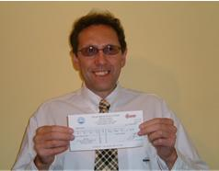
THE FRONT VIEW OF YOUR WINNING

