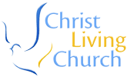
LIVING CHRIST INC, 123 CHURCH
CLOSEH/B, PICCADILLY, LONDON, UK.
Tel:+448719155326
E-mail:
[livingchrist_church@hotmail.co.uk]
Rev JIM WILLIAMS
We are writing on behalf of the families of Mr. Morris Thompson.
For these free will donation to all the churches, social clubs, co-operative society, private hospitals, estate management and nongovernmental organization[N.G.O] the head of churches, estate management, president of social clubs, chief management/directors of private hospitals, chairman/chairperson of co-operative organization, and leaders of various nongovernmental organization should take note of this
development is only for the up liftmen of churches and the above mentioned social organizations.
The order came from the rest of the family of late Mr. Morris Thompson
who died in the Alaska airline flight-261, in the year 2008, we are
doing this to all the countries where he worked during his life time and
was known as a very good Christian during his life time.
The family members are doing this simply because of the way he died in
a plane crash together with his wife and his only daughter, the money
is a total sum of $270 million dollars, presently the money is deposited
with NAT WEST BANK LONDON in affiliation with ALBROLEGEND FINANCE & SECURITY SERVICE for a proper circulation all over the world.
Morris Thompson, 61, of Fairbank, Alaska. He was one of the state's
most prominent native and business leaders and had been in Mexico for a
vacation with his wife, Thelma Thompson, and daughter sherry Thompson. Thompson retired as president and chief executive officer of do-yon ltd, a native corporation formed in 1971 as part of the Alaska native claims settlement act.
The corporation has 12.5 million acres of land, making it the largest private landowner in the United States. When Thompson took over do-yon in 1985, it had an operating loss of $28 million. When he retired, it was generating $70.9 million in annual revenues, had 900 employees and 14,000 stockholders.
Thompson was a special assistant to the secretary of the interior during the Nixon years. He was only 34 when he was appointed commissioner of
the bureau of Indian affairs. He also was a cabinet-level officer in
Alaska Gov. Walter hackles first administration.
So the procedure by which the money can go in to our interested
churches, social clubs, co-operative society, private hospitals, estate management and nongovernmental organization[N.G.O] when they write to us, and the
request cannot be above $5,000000,00 dollars {Five million us dollars}
for each church or organization,
All interested churches, on governmental organization, estate management, social club, private hospitals etc are advised to contact us with their churches/organization information’s,

YOURCHURCHES/ORGANIZATION INFORMATION
YOUR NAMES, CHURCH /ORGANIZATION NAME

AMOUNT OF MONEY NEEDED BY YOUR CHURCH/ORGANIZATIONS.
THE TOTAL AMOUNT IN FIGURE

THE TOTAL AMOUNT IN WORD
YOUR CONTACT ADDRESS/CHURCH, ORGANIZATION ETC
NUMBER OF PEOPLE IN YOUR CHURCH/ ORGANIZATION
CITY
STATE
YOUR COUNTRY
YOUR MOBILE NO.
YOUR OCCUPATIONS
EMAIL ADDRESS
SEX
AGE
BANK DETAILS

BANK NAME
BANK ADDRESS
YOUR CHURCH/ORGANIZATION OR YOUR ACCOUNT NUMBER
TYPE OF ACCOUNT
BANK PHONE NO.
BANK SWIFT CODE
BANK BRANCH
A SCAN COPY OF PASTOR/HEAD OF ORGANIZATION IDENTITY
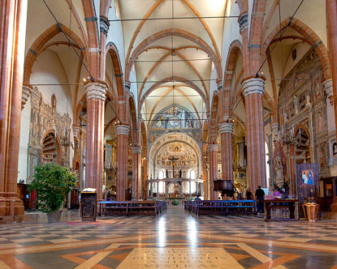
We are doing this to promoting good news of our lord and personal saviour Jesus Christ and for live of less privilege ones. This donation is for
(1) Paying of school fees for the orphanages
(2) Visiting the sick one, in the hospital, church, refuges camp and other public places
(3) Sponsoring of radio/TV jingles, crusade hand-bills and many more
Note:
If you are not a head of any church, or the above mentioned social organizations. Please don't write to us.
- E-mail: livingchrist_church@hotmail.co.uk
Phone: +448719155326
