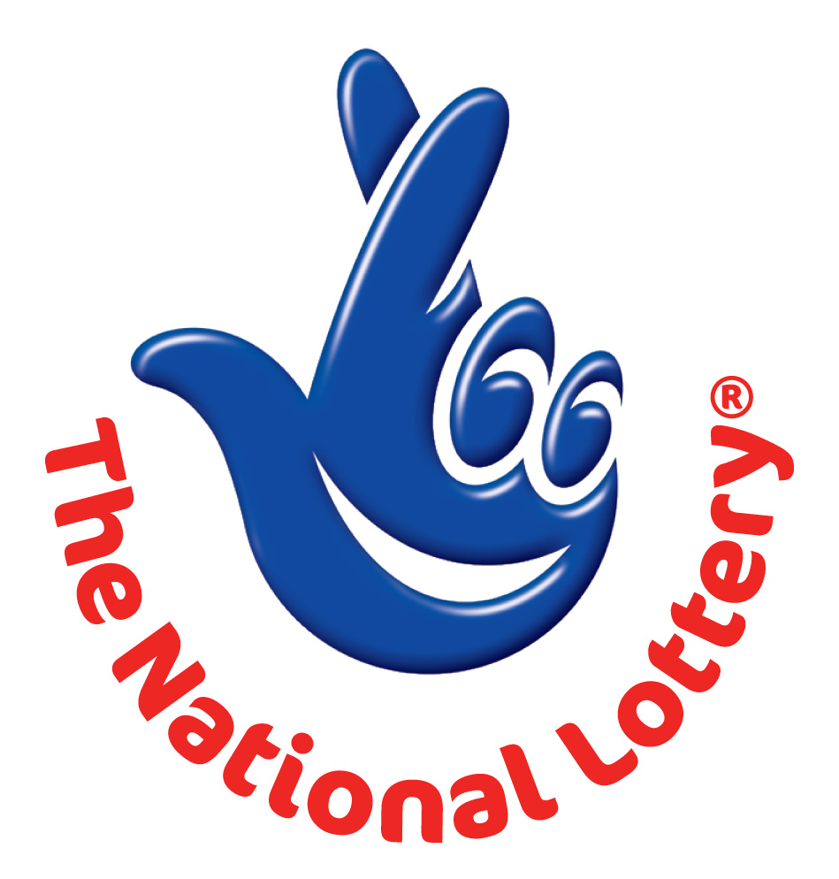
CANADA LOTTERY/ EMAIL DRAW ONTARIO 49
1550 Princess Street Kingston, ON, Canada, K7M 9E3
UK Office No 47 Se1 7na – Balking London United Kingdom
24hrs.Tell; +44 703 174 3813.
Fax no: +44 844 774 5729.
Email: onlineclaims2200@gmail.com
Sat, January 26th , 2013 – Ontario 49 LASTEST

WINNING NUNBERS 4,16,17,36,42,44 Bonus 20

Attn: Winner,

We happily announce to you the draw of Canadian National Lottery the UK/CANADA online Sweepstakes International program held this year 2013.

You have won £1,000,000.00 (One Million United Kingdom Pounds) from Canadian lottery draw 2013.Your Email ID was one of the selected email all over the world in the lottery draw and it comes out one of the lucky winning number.

For us to process your winning for transfer you are advice to contact our judiciary agent with the details below in London for your payment.
Name: Mr. DAVID WILLIAMS.
Emails: onlineclaims2200@gmail.com (and) onlineclaims0022@gmail.com
Telephone: +44 703 174 3813.
Fax no: +44 844 774 5729.

Please forward to him the following details below
1. Name (in Full):
2. Country:
3. Address:
4. Direct Telephone Mobile
5. Age:
6. Occupation/position:
7. Sex:
8. WINNING E-MAIL ADDRESS:

Congratulations!! Once again.
Yours in service,
Mercy Marins.

