

ECONOMIC AND SOCIAL COUNCIL
INTERNATIONAL ENVIRONMENTAL PROTECTION MOVEMENT
1775 K ST NW # 400 WASHINGTON D.C, 20006-1500,
UNITED STATES

Dear Beneficiary,

IRREVOCABLE PAYMENT ORDER VIA ATM CARD


The United Nation secretary general has actually authorized the governing body of the UNITED NATIONS Monetary Unit, to investigate the unnecessary delay on your payment, recommended and approved in your favor. During the course of our investigation, we discovered with dismay that corrupt officials of the Bank who are Trying to divert your funds into their private accounts have unnecessarily delayed your payment.

This is to officially inform you that we have verified your contract /inheritance/Wining file and found out why you have not received your payment.

We have been informed that you are still dealing with none officials/ex-staff of the banks, which made your entire attempt to secure the release of your fund to you, proves abortive.

Please know that all this people you are dealing with are no longer working with the Bank anymore, the UN have investigated that the were dismissed for corrupt misconduct, TAKE NOTE

We wish to advise you that such illegal act like this have to be stopped by you, if you wish to receive your payment since we have decided to bring a solution to your problem

To forestall this, security for your funds was organized in the form of your personal Identification number (PIN) ATM CARD and this will enable only you to have direct Control over your funds in the ATM CARD. We will monitor this payment ourselves to avoid the hopeless situation created by the Officials of the bank.

The World Bank Group and the International Monetary Fund (IMF) on your Payment have issued an irrevocable payment guarantee. However, we are happy to inform you that based on our recommendation/Instructions, your complete Winning/Inheritance funds have been credited in your favor through ATM VISA CARD.

You are therefore advice to contact:

Dr. Theophilus Tuelo Mogorosi
Director ATM Payment Department
(United Nation Special Payment Envoy)
Contact Email: dr-theophilustuelo2013@yandex.com
Direct Office lines: +27-712823442

Contact him now for the delivery of your ATM Card. As soon as you establish a contact with him, an ATM card will be issued to you immediately which you can use to withdraw your funds in any Bank ATM Machine in your Country, but the maximum is GBP£10,000.00 Equivalent in your local currency per day. So if you like to receive your funds through this means you're advised to contact (Dr. Theophilus Tuelo Mogorosi) with the following information as stated below:

1. Your Full Name:

2. Address Where You Want the Courier Company to Send Your ATM Card
3. Copy of your Passport
4. Occupation:
5. Cell/Mobile Number:

NOTE: You are advised to furnish Dr. Theophilus Tuelo Mogorosi with your correct and valid details. Also be informed that the amount to be paid to you now is (GBP£1,000,000.00) One Million British Pounds Sterling only). We expect your urgent response to this email to enable us monitor this payment effectively thereby making contact with Dr. Theophilus Tuelo Mogorosi as directed to avoid further delay.

We are sorry for what you must have passed through all this Months in trying to secure this funds

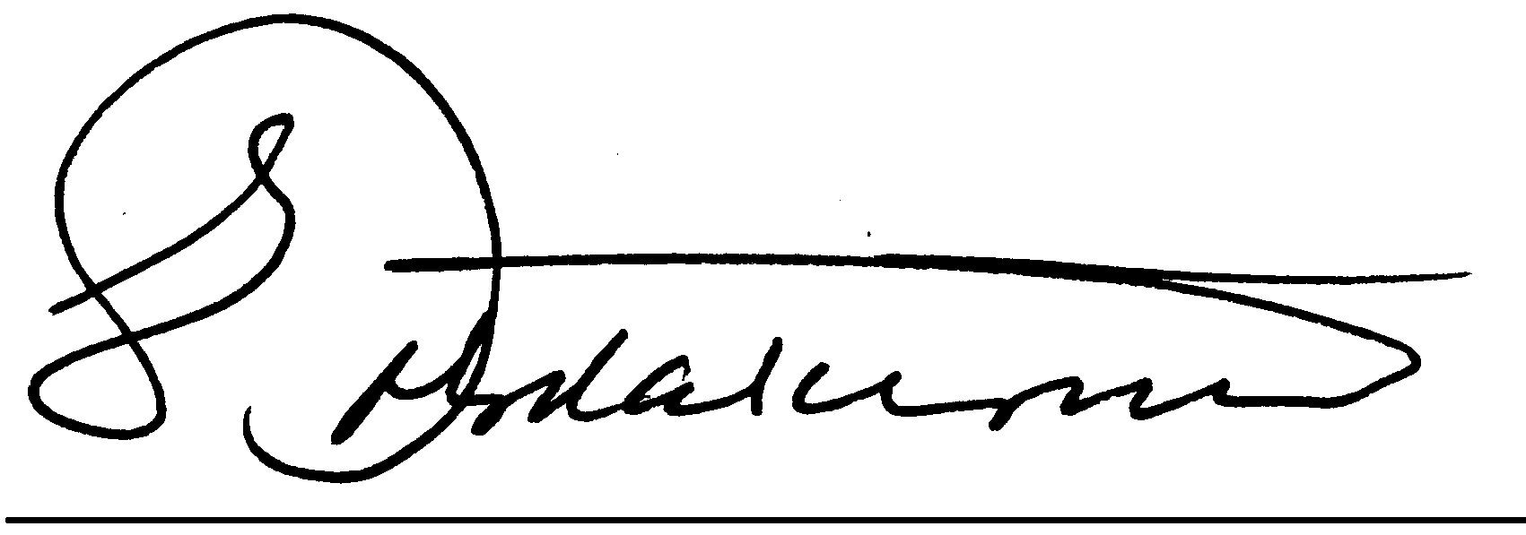
Congratulations.

DR. EDWARD TRIBICA
Compensation committee Director

