
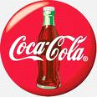

PO Box 1010, Liverpool
L70 1NL, United Kingdom,
THE NOKIA MOBILE PROMOTION/PRIZE AWARD DEPT
35 NEWTOWN JOHANNESBURG SOUTH AFRICA
ATTENTION: WINNER,
NOKIA MOBILE COMPANY & 2014 COCA-COLA OFFICIAL AWARD NOTIFICATION
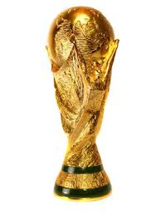
We are pleased to inform you of the result of 2014 draws held on the 28th Nov, 2013 by Nokia Mobile Company in conjunction with the COCA-COLA Promotion committee London United Kingdom, your email was among the 10 Lucky winners who won ($500,000.00) Five Hundred Thousand United State Dollars each on the NOKIA COMPANY AND COCA-COLA LOTTO AWARD PROMOTION.

However the results were released on the (28 Dec, 2013) and your email attached to ticket number (2PYUK2010) and ballot number (UK: 51322010/110) were among the lucky winners. The online draws was conducted by a random selection of email addresses from an exclusive list of 29,031 E-mail addresses of individuals and corporate bodies picked by an advanced automated random computer. However, no tickets were sold but all email addresses were assigned to different ticket numbers for representation and privacy.

PAYMENT PRIZE AND CLAIM
Winners shall be paid in accordance with his/her Settlement Centre. Nokia Prize Award must be claimed no later than 90 days from the date of Notification. Any Prize not claimed within this period will be forfeited.

You are requested to contact your claim agent in South Africa and send your winning details to him;

NAME: Mr. Douglas Michael
Mobile Phone: +27760347688
E-mail: mr.douglas.michael01@gmail.com

You are advised to send the following information for urgent release of your winning fund to you.
(1) NAME: ........
(2) AGE: ............................
(3) SEX: .................................
(4) ADDRESS: ............................
(5) EMAIL: ……………………………….
(6) CELL PHONE: ......................................
(7) OCCUPATION: ..........................................
(10)COUNTRY: .............................................................. ............
(11)AMOUNT WON: …………………………………….……

Congratulations!! Once again yours in service,
[Signed By: Mr. Muhtar Kent, Chairman of the Board and Chief Executive Officer]

