


BRAZIL TO HOST CHIEL IN FIFA
CONFEDERATIONS CUP WARM-UP
FIFA 2014 Microsoft Online Promotions
Microsoft London (Cardinal Place)
100 Victoria Street London SW1E 5JL
REF: FIFA/MOP/2013-2014
Contact FIFA Manager 2014 Mrs. Rose Smith
Tel: + 44 793 741 7087 or + 44 793 741 9600
Fax: + 44 872 331 2915

THIS IS TO REMIND YOU AGAIN THAT YOU HAVE WON A TICKET TO GO TO Brazil 2014 FIFA World Cup, you have won SUM of (Five Hundred Thousand United State Dollars) by your E-mail Adders. We wish to congratulate you once again on this note, for being the legal beneficiary/User of this selected e-mail address, Selected for the Fife 2014 Microsoft online promotional Awards. There was a computer ballot that was organized by the FIFA and MICROSOFT NETWORK.

Microsoft Online Network and was sponsored by FIFA at Johannesburg, South Africa. This promotion was held in South Africa because of the successful FIFA 2010 WORLD CUP that was hosted in South Africa (2010) and the main aim of this award, is to promote the up coming FIFA 2014 WORLD CUP that will be host in Brazil.

FIVE (5) email addresses was finally picked out from among the Total (1,000,000.00) email addresses, and out of those (65) email addresses, your Email address is among the winning e-mail address on the winning Pot, which was attached For your Security code FIFA/+ QU34005 and Ticket Pin Code Number: 1214 to Winning Numbers: REF FIFA/MOP/2013-14 21 30 39 40 47 and Bonus Number is (31) and Winning Amount won is (Five Hundred Thousand United State Dollars) Now we want to know how you would like to receive your 2014 Brazil FIFA AWARD either by BANK TO BANK TRANSFERS OR BY CHEQUE.

YOUR TICKET PIN CODE NO: XX 1214.

You are requested to contact your CLAIM AGENT in South Africa and send your payment details to him;
(CONTACT YOUR CLAIM AGENT) NAME: MR JAMES TAWA.
Contact Email: jamestawa2013@gmail.com
You are advised to send the following information to your to him to release of your winning Fund to you.
(1) NAME:....................... (2) BONUS NUMBER...............
(3) AGE:.......................... (4) WINNING NUMBERS:......
(5) SEX :........................... (6) SECURITY CODE:.............
(7) ADDRESS:................ (8) AMOUNT WON:.................
(9) EMAIL :...................... (10) TEL AND FAX NUMBER:
(11)OCCUPATION :…….(12) COMPANY:........................
(13)STATE/CITY:……….(14)COUNTRY:.........................
(15) NATIONALITY:….. (16)TICKET PIN CODE:……..
(17)AMOUNT WON :.......( 18) MARITAL STATUS:……
(20)Once your agent acknowledges receipt of this required detail, transfer would commence.

Congratulations Once again!
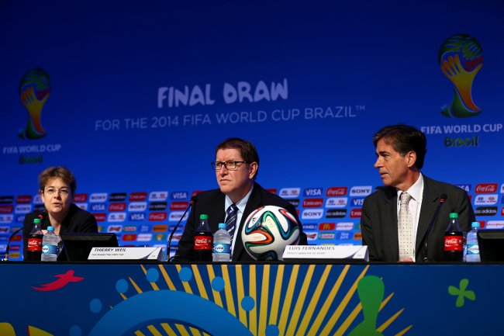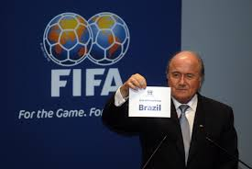
Yours in service, DIRECTORS AND CEO 2014 OF FIFA WORLD CUP IN BRAZIL
Manager Mrs. Rose Smith Contact Email mrsrosesmith20@gmail.com

